Name: ____________________________________________ Date: ___________ Pd: _____ Grp #: ______

Lesson 3: Understanding the Utilization of Glucose Throughout the Body (Part 1)

You will look at some data to determine how much energy each of your organs/tissues actually use. Fill in the % Energy Consumption data in the table below. Record ALL numbers to the 100th spot of a decimal, please.

% Energy Consumption = (Energy consumption per tissue) X 100%
Total Energy

Table 1: Calculate energy consumption per organ/tissue.
Organ or Tissue | Energy Consumption (kCal) | Energy Consumption (%)
Adipose (fat) | 67.5
Muscle | 366.6
Liver | 360
Brain | 336
Heart | 120
Kidney | 120
Other | 278.4
TOTAL | 1648.5 | 100
To understand how much energy each of your organs/tissues actually uses, we need to determine how large each organ actually is (what % of your total body weight). With this information, we can then calculate the ratio of % energy consumption to % of total body weight.
% Body Weight = (Weight per tissue) X 100%
Total Weight

Table 2: Calculate energy consumption per organ/tissue.
Organ or Tissue | Weight (lbs) | Body Weight (%)
Adipose (fat) | 33
Muscle | 62.17
Liver | 3.96
Brain | 3.08
Heart | 0.66
Kidney | 0.66
Other | 51.5
TOTAL | 155.03 | 100

Why is it helpful to know what percent of total body weight each organ comprises? Why is this important to compare to % energy consumption?

OVER
Table 3: Glucose Utilization Ratio (% Energy Consumption ÷ % Body Weight)
**Note: these numbers will NOT be multiplied by 100 like the other 2 tables!
Organ or Tissue | Glucose Utilization Ratio
Adipose (fat)
Muscle
Liver
Brain
Heart
Kidney
Other
TOTAL
**For each ratio, divide the % energy consumption by the % body weight from the previous calculations. You can round your answers to the nearest 10th.

Draw a pie graph to represent the data (% energy consumption) in Table 1. Use TAILS!

Draw a bar graph (histogram) to represent the data (% energy consumption) in Table 1. Use TAILS!

Name: ____________________________________________ Date: ___________ Pd: _____ Grp #: ______

Lesson 3: Understanding the Utilization of Glucose Throughout the Body (Part 1)

Diabetes is a disease affecting the insulin producing cells of the pancreas. If there is not enough insulin being produced by these cells, the amount of glucose (sugar) in the blood will remain high. A blood glucose level above 140 for an extended period of time is not considered normal. This disease, if not brought under control, can lead to sever complications and even death. Graph the following data into a line graph then answer the questions under your graph. Use TAILS!

Table 4: Blood Sugar Levels After Eating in Different Patients
Time After Eating (hours) | Glucose in Blood in Person A  (ml / Liter) | Glucose in Blood in Person B  (ml / Liter)
0.5 | 170 | 180
1.0 | 155 | 195
1.5 | 140 | 230
2.0 | 135 | 245
2.5 | 140 | 235
3.0 | 135 | 225
4.0 | 130 | 200
a) Which, if any, of the above individuals (A or B)
could have diabetes? WHY?

b) Do you think this person has type 1 or type 2 Diabetes based on the reading and graph? Use evidence from this question to support your answer.

Name: _____________________________________________ Date: ____________ Period: ____

Lesson 3: Blood Glucose Negative Feedback Model (Part 2)

Blood glucose is controlled by negative feedback. Specialized cells in the pancreas detects the level of glucose in the blood. Both insulin and glucagon are hormones that are produced and released by the pancreas. Please look at the graph below to answer the following questions and draw out the negative feedback model on the back.

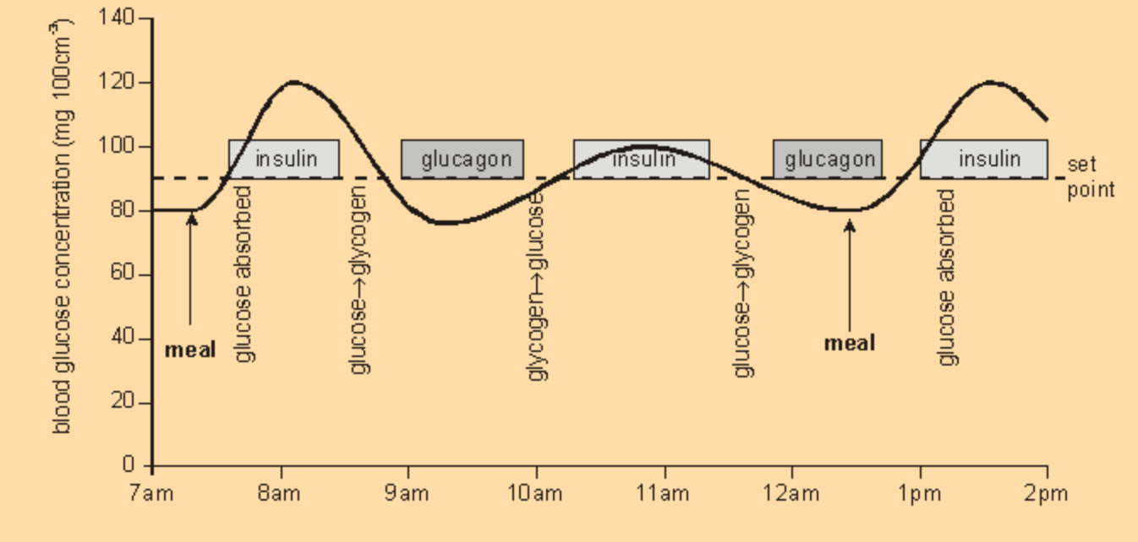

- What times did the individual eat? ____________ and _____________

- What is the set point for blood glucose? _________

- When is insulin produced? Provide evidence from the graph to support your answer.

- When is glucagon produced? Provide evidence from the graph to support your answer.

- Construct an explanation describing the effect of insulin on blood glucose.

- Construct an explanation describing the effect of glucagon on blood glucose.

- Fill in the Set Point Model on the next page using the information gained in Part 2 of this lesson.

Blood glucose regulation

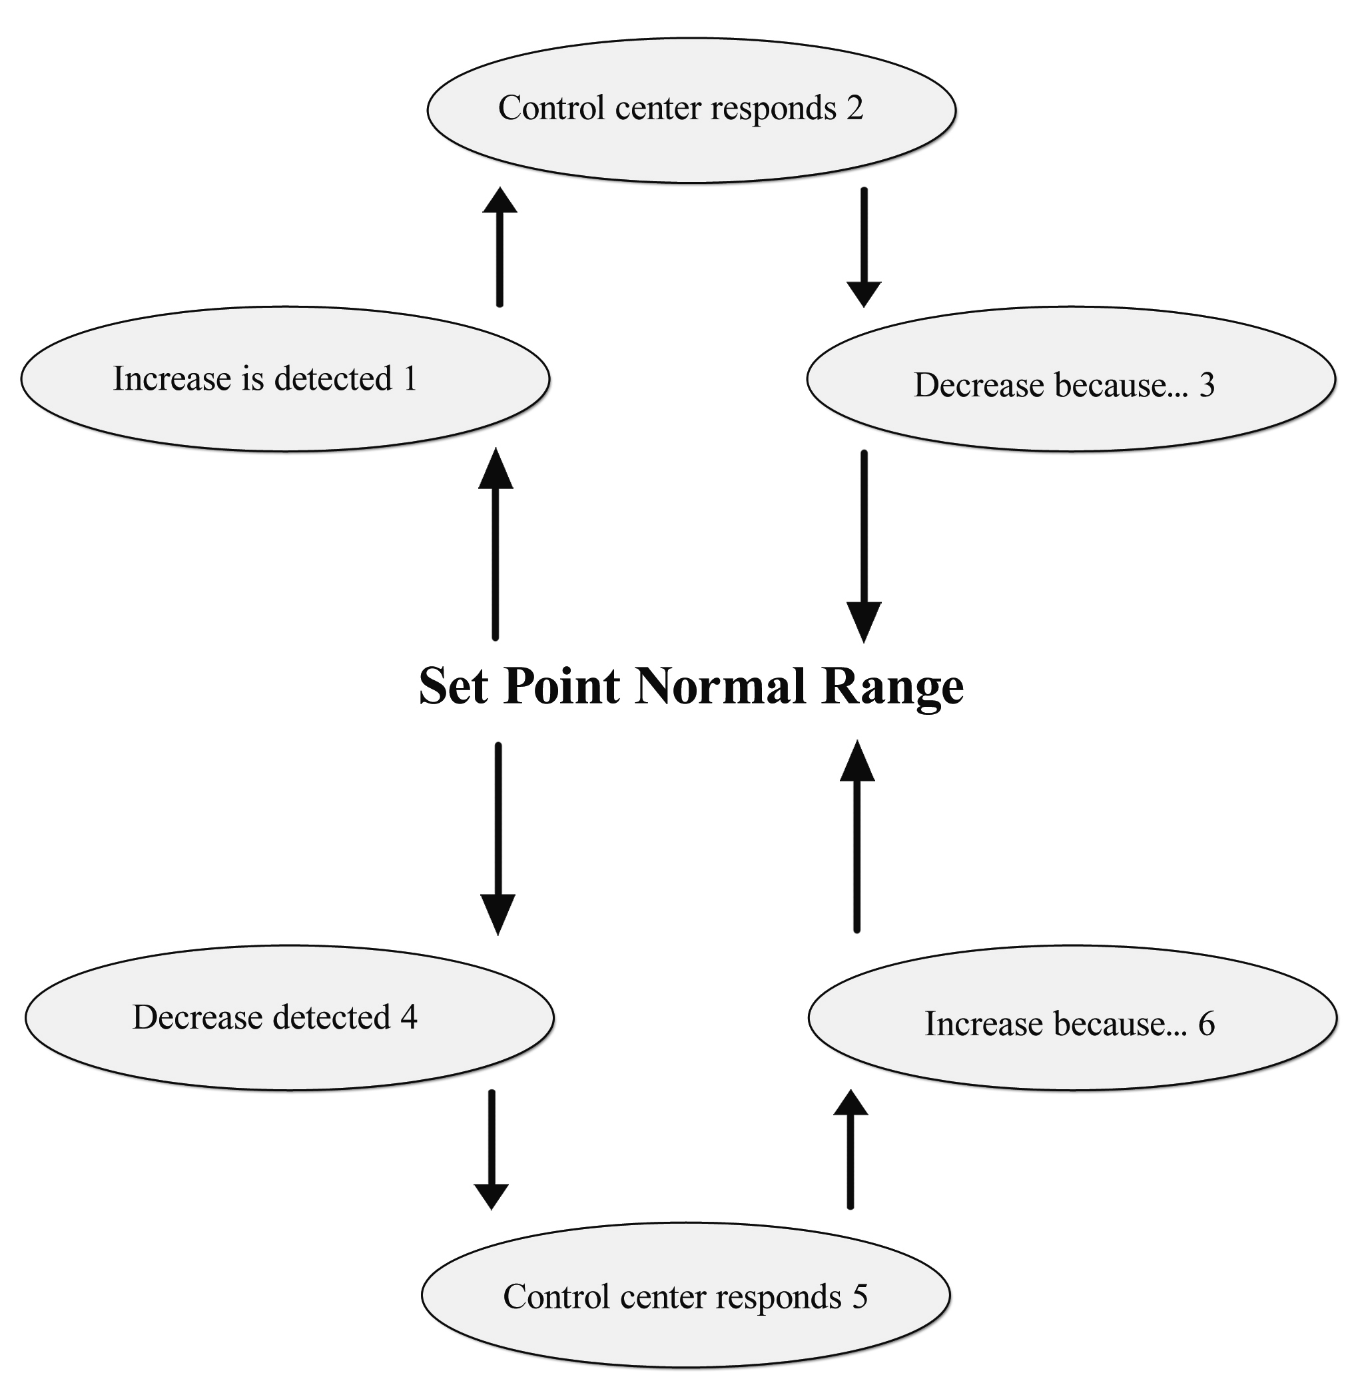

Name: ____________________________________________ Date: ___________ Pd: _____ Grp #: ______

Lesson 3: Understanding the Utilization of Glucose Throughout the Body (Part 3)
WEBQUEST

Now, go to the following website: https://learn.genetics.utah.edu/content/metabolism/pathways/ to complete the worksheet below.
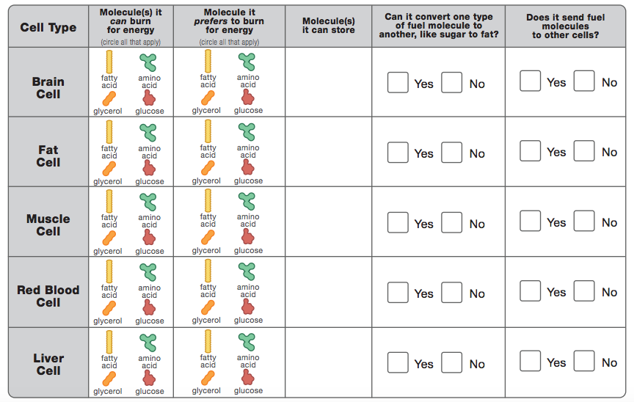

What did you learn in this webquest that surprised you the most? Note: “Nothing” is not an acceptable answer.

