Negative feedback vs. Positive Feedback Notes (Ms. Day/Honors Biology)

Watch the following video and take notes:
https://www.youtube.com/watch?v=Iz0Q9nTZCw4 (6:24 min)
https://www.youtube.com/watch?v=R6_oe_QcHKc (2:25 min)

- What is homeostasis?

- Fill in the table below:
 | Negative Feedback | Positive Feedback
How you’re your body react to a change?
- Counteracts a change or
- Amplifies (intensifies) the changes
Keeps homeostasis?
- Yes
- No
Other Notes/Examples of:

Now, watch the following video and tale notes:
https://www.youtube.com/watch?v=5G3aKGGI8hw (4: 56 min)

- What are 2 types of “sensors” in your body? ________________________ & ___________________
More notes:

- What is an example of a “integrator/ control center” in your body? _____________________________
More notes:

- What are 2 types of “effectors” in your body? _________________________ & ___________________
More notes:

NEGATIVE FEEDBACK

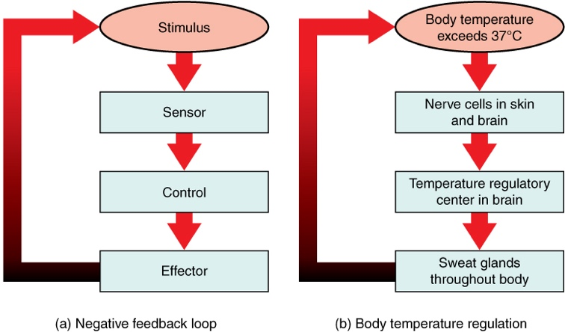
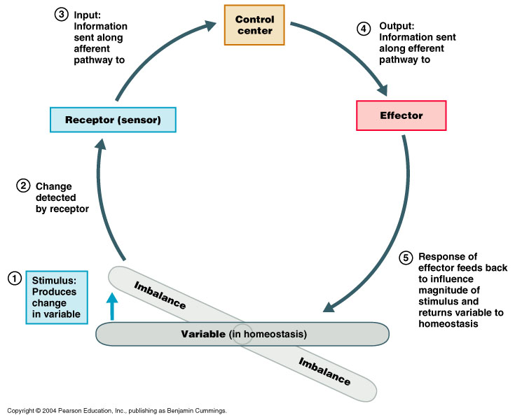

POSITIVE FEEDBACK

