Name: __________________________________________________________ Date: ______________________Ms. Day/ Honors Biology

Geochemical Cycles PPT Guide #40 (____/40)
- Fill in the table below:
Element | Why is this element important to life?
- Carbon

- Nitrogen

- Phosphorus

- Water

WATER CYCLE:
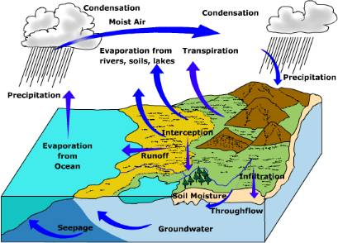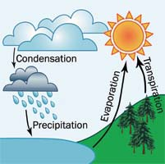
- Fill in the table:
Part of cycle | Definition
Evaporation

Condensation

Precipitation

Transpiration

CARBON CYCLE:
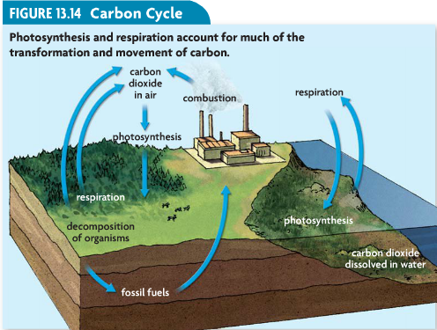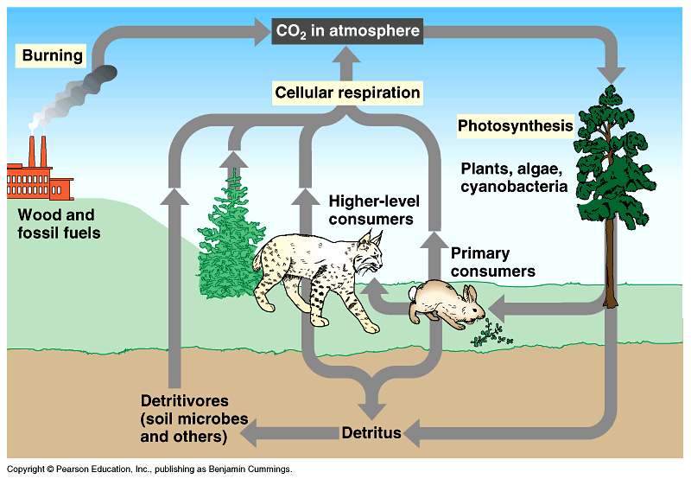
- What 3 processes does the carbon cycle use to recycle carbon from biotic to abiotic factors in an environment?

  - _____________________________________________________
  - _____________________________________________________
  - _____________________________________________________

- What are fossil fuels?

- What are greenhouse gases?

- Name 4 different greenhouse gases:
  - ______________________________ c. _____________________________________
  - ______________________________ d. _____________________________________
- Where does CO₂ come from? ________________________________________ & _________________________

- What is the greenhouse effect?

- Is the greenhouse effect GOOD or BAD? ____________ Good ______________Bad (Check one)

- What is the ozone layer?

- Fill in the boxes below:
What is the chemical formula for ozone? | Why is the ozone layer good from us? | What is happening to the ozone layer? | Why is this happening to the ozone layer?

- What are the 3 reasons for CLIMATE CHANGE?
  - ________________________________________________________________
  - ________________________________________________________________
  - ________________________________________________________________
- Name the 7 things (effects) that are caused by global warming?

NITROGEN CYCLE:
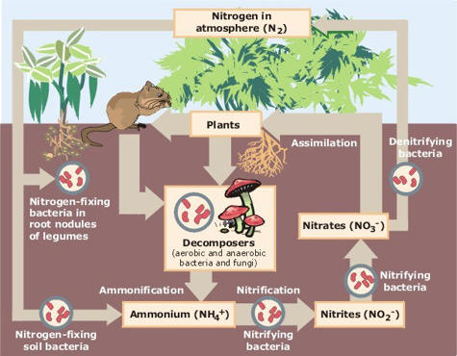
- What is N₂? _______________________________________________________________________________

- Why do we need “nitrogen fixing” bacteria?

- What puts back N₂ into our atmosphere? _________________________________________________________
- What kind (forms) of nitrogen can animals and plants use? ___________________________________________
PHOSPHORUS CYCLE:
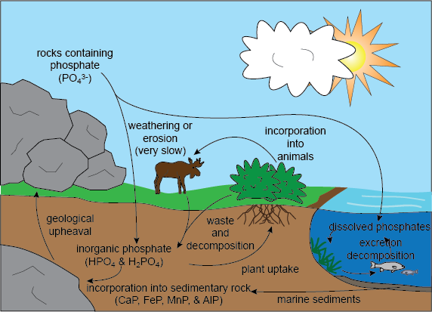
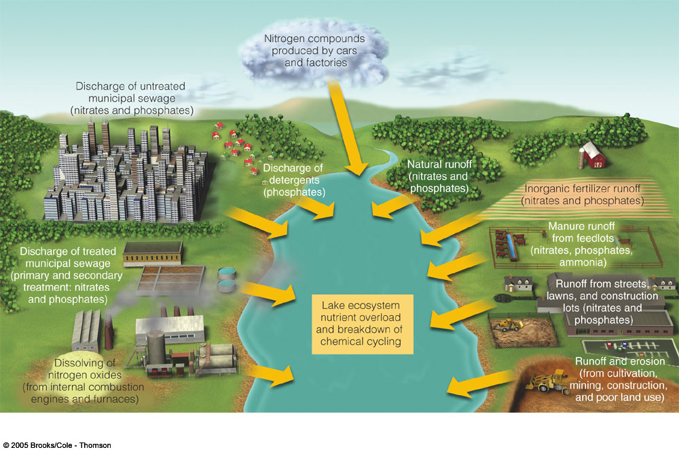
- Where can phosphorus be found? __________________________________________________________________

- The element phosphorus CANNOT be found in what state of matter? _____________________________________

- Where do plants and animals get their phosphate?

- What is eutrophication?

